Meet Patoliya

RoLL No: 150101045

User Manual

No dues portal within IIT Guwahati

# Users

|  |  |
| --- | --- |
|  |  |
| Students | Students enrolled in IIT Guwahati |
| Faculties | Faculties of various departments of IIT Guwahati |
| Lab/workshop Instructors | Lab admins of various lab/workshops of IIT Guwahati |
| HODs | Head of departments of various departments in IIT Guwahati |
| Caretakers | Caretakers of various hostels of IIT Guwahati |
| Wardens | Wardens of various hostels in of IIT Guwahati |
| Gymkhana | Gymkhana admin of IIT Guwahati |
| Assistant registrar | Assistant registrar of IIT Guwahati |
| Online CC admin | Online CC admin of IIT Guwahati |
| CC admin | CC admin of IIT Guwahati |
| Thesis manager | Thesis manager(s) of IIT Guwahati |
| Library | Library admin(s) of IIT Guwahati |
| Account | Account admin(s) of IIT Guwahati |

# Required information for various profiles:

These are the required details of various profiles:

|  |  |
| --- | --- |
|  |  |
| Student | * Name * Roll Number * Webmail * Department * Hostel |
| Faculty | * Name * Webmail * Department |
| Lab/workshop Instructor | * Name * Webmail |
| HOD | * Name * Webmail * Department |
| Caretaker | * Name * Webmail * Hostel |
| Warden | * Name * Webmail * Hostel |
| Gymkhana | * Name * Webmail |
| Assistant registrar | * Name * Webmail |
| Online CC admin | * Name * Webmail |
| CC admin | * Name * Webmail |
| Thesis manager | * Name * Webmail |
| Library | * Name * Webmail |
| Account | * Name * Webmail |

# Hierarchy of No Dues Clarification

|  |  |  |  |  |  |
| --- | --- | --- | --- | --- | --- |
| Caretaker | Gymkhana | Online CC | Thesis Manager | Lab/Workshops | Faculties |
| Warden | CC | Library |
| Assistant Registrar | |
| HOD | | | | | |
| Account | | | | | |

The users below the others can see pending request of student and approve him only after all users above him approve a student.

The status change by user from ‘Approved’ to ‘Not Approved’ will result in ‘Not Approved’ status by all other dependent users for particular student.

# Login

User have to enter webmail login credentials.

User have to select appropriate role. Users with multiple roles will be redirected accordingly.

This is how login page look like:

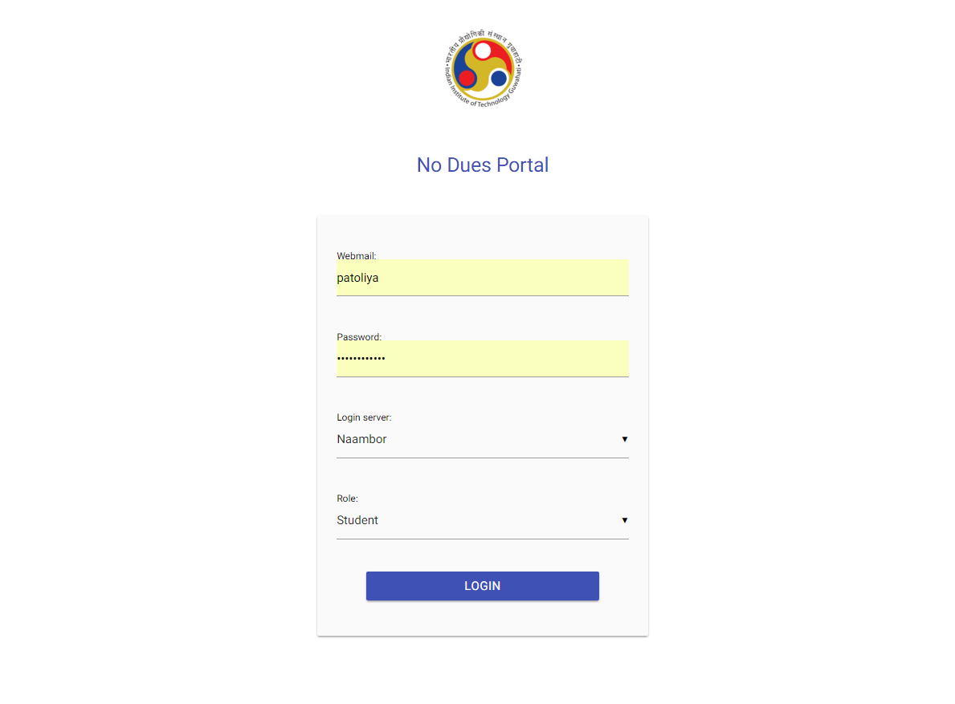

# Student Profile

## Student can see the overall status:

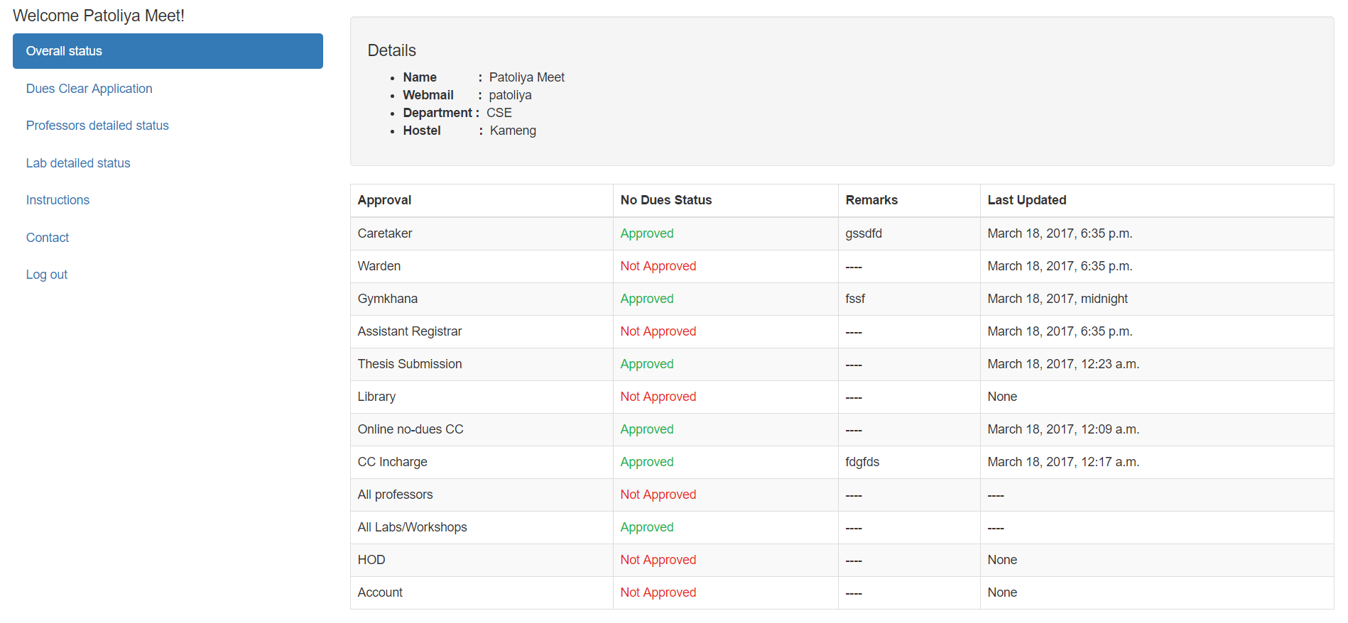

## Student can apply for no dues clarification by different sections:

Student have to add at least one faculty before he applies for clarification by faculties.

Student’s dues clarification process starts only once student apply for particular section.

The reversal of application of particular section will result in resetting student’s approval status for that section and all other dependents to “Not Approved”

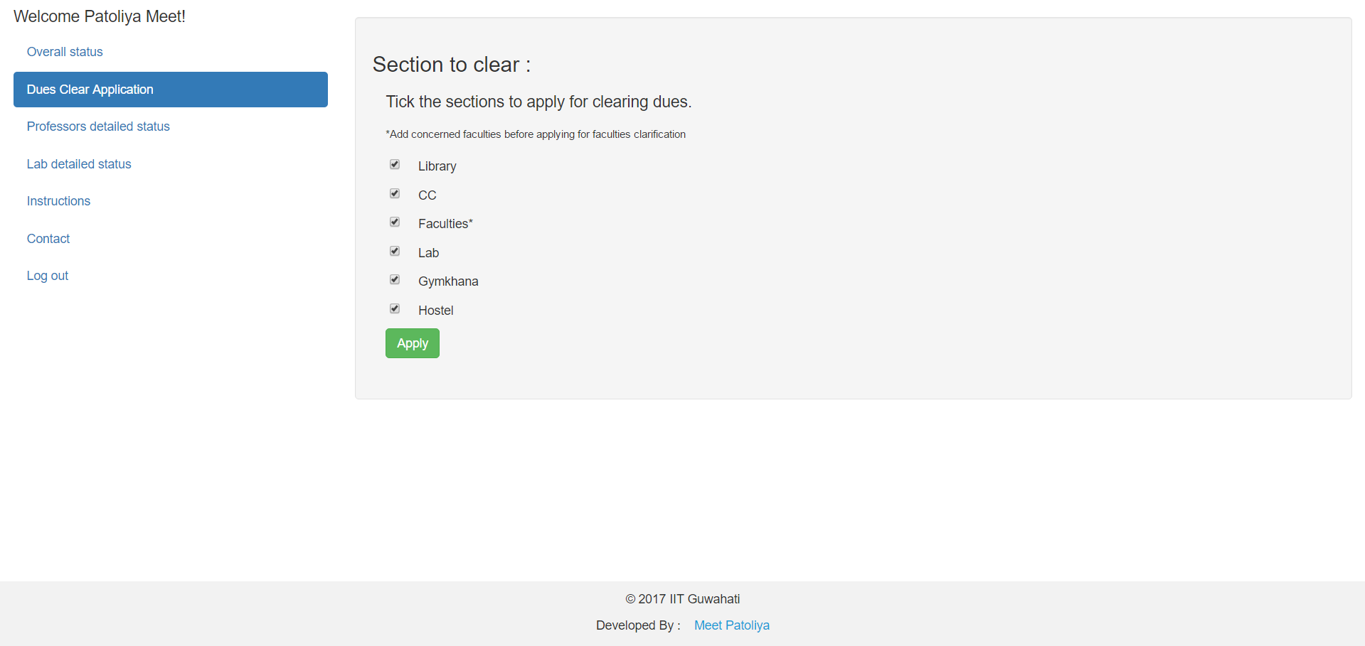

## Student can see detailed faculty approval status:

Student have to add BTP/MTP faculties and other concerned faculties manually.

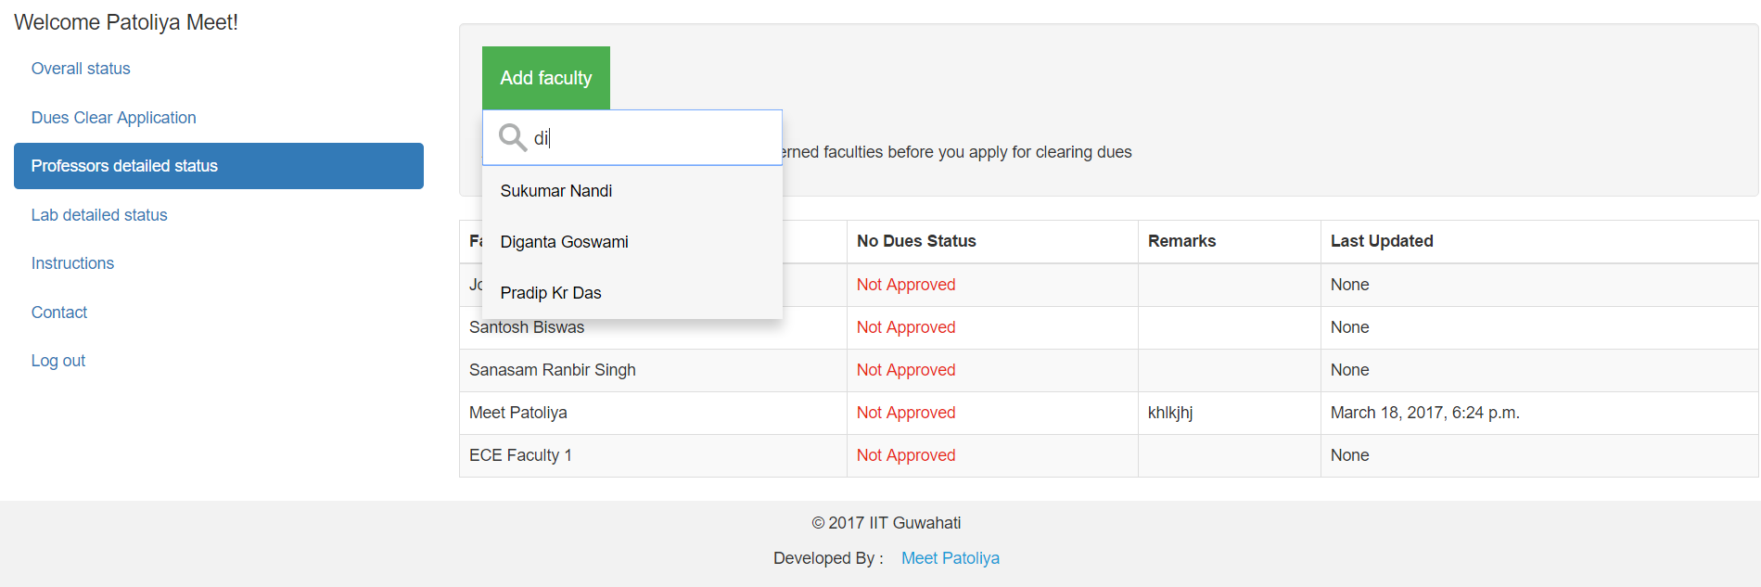

## Student can see detailed lab/workshops approval status:

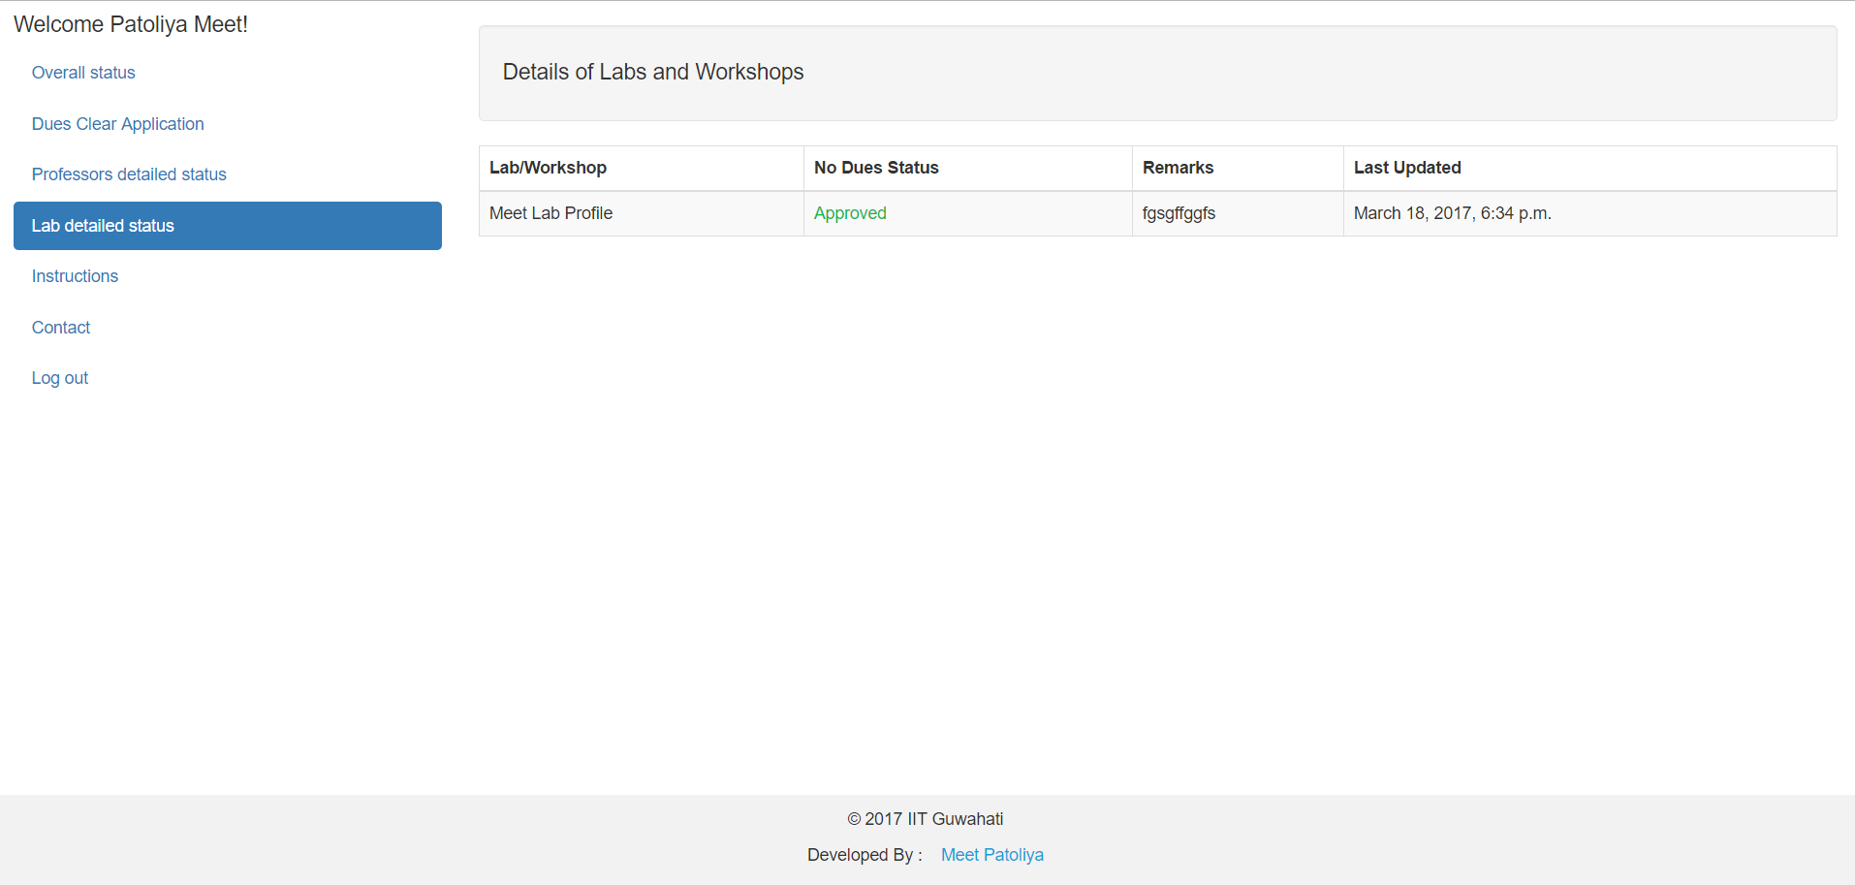

# Faculty Profile

Faculty can add student by clicking on ‘Add student’ button and searching a student by any detail of student. New added student will appear in ‘Pending’ section once he applies to clear dues by faculties.

Faculty can delete student a student just by clicking n ‘Delete’ button and confirming it.

Faculty can change the status of student by toggling a checkbox. On clicking, that student will immediately move to another table.

Faculty can change the status of all students in table simultaneously by clicking on ‘Toggle all’ checkbox.

Faculty can make remarks for particular student in remarks column

Faculty can sort students by clicking on corresponding column header.

Faculty can search students using universal search bar.

Faculty can see as much students as he wants in one page.

This is how pending request tab looks like:

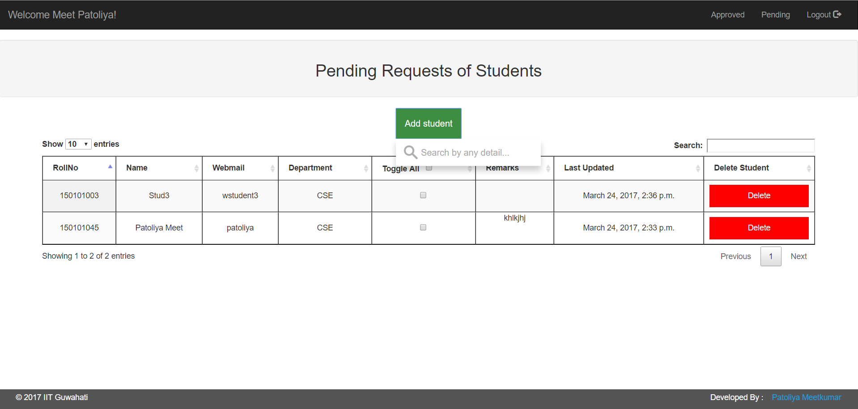

This is how tab of approved students looks like:

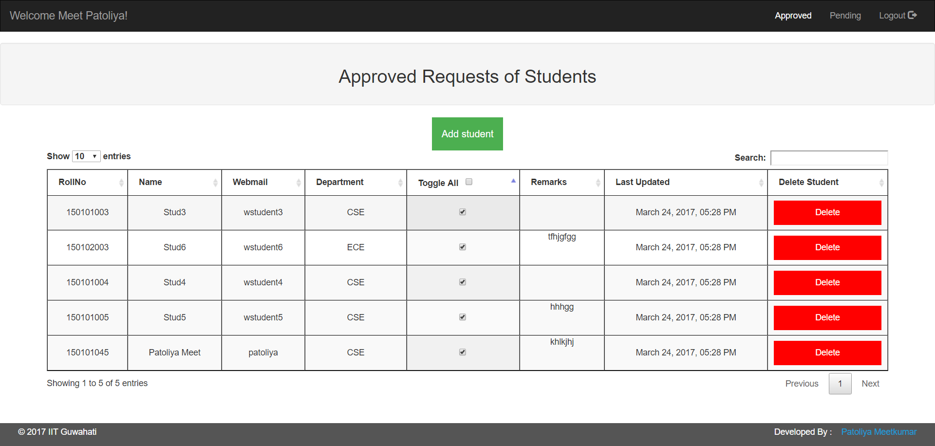

# Various other user profiles

Following users will fall under this category:

|  |  |
| --- | --- |
| **Lab/workshop Instructor profile** | **Online CC admin profile** |
| **HOD profile** | **CC admin profile** |
| **Caretaker profile** | **Thesis manager profile** |
| **Warden profile** | **Library profile** |
| **Gymkhana profile** | **Account profile** |
| **Assistant registrar profile** |  |

User can change the status of student by toggling a checkbox. On clicking, that student will immediately move to another table.

User can change the status of all students in table simultaneously by clicking on ‘Toggle all’ checkbox.

User can make remarks for particular student in remarks column.

User can sort students by clicking on corresponding column header.

User can search students using universal search bar.

User can see as much students as he wants in one page.

This is how pending request page looks like:

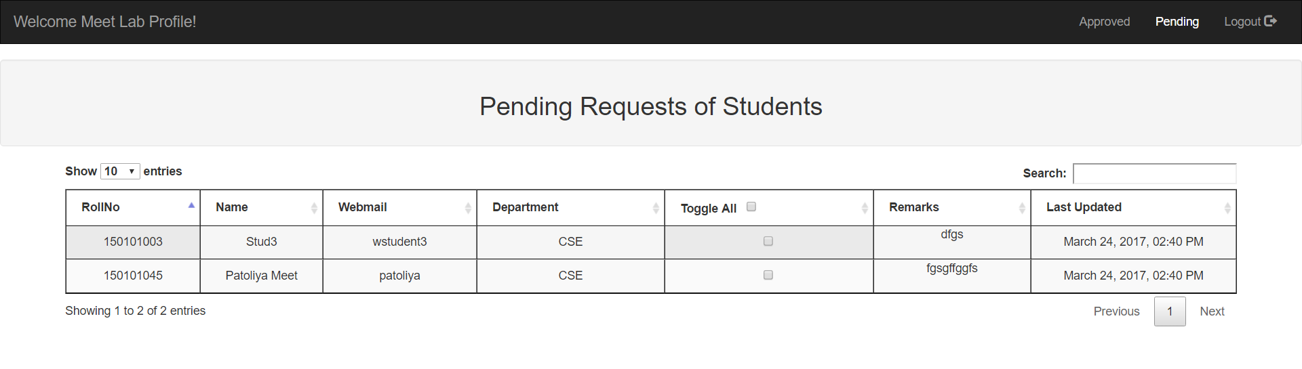

This is how approved request page looks like:

